Michael’s Story
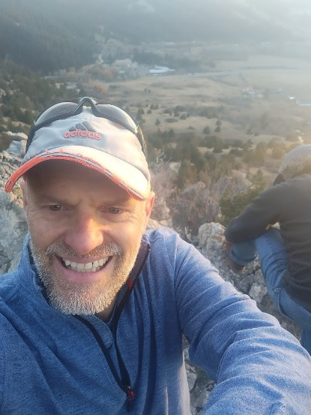
The Journey to Mastering Oneself
The journey to mastering oneself isn’t a straight path; it’s shaped by real-life experiences
.
My Journey Begins
My own journey started in the vibrant and challenging world of South Africa. Growing up under strict expectations, I developed a keen sensitivity and an loving, observant nature. However, I quickly learned to hide it behind the bravado expected of a young man trying to find his way.
The Typical Path to Success
For many years, I followed the typical path to success. I earned a business degree and worked my way through the demanding world of corporate finance. I climbed the ranks in the high-pressure Reinsurance industry.
By my late twenties, I was:
- A director
- Negotiating multi-million dollar contracts across Europe and London
- Driving luxury cars
- Living what I thought was the corporate dream
I had achieved the life I believed I was supposed to want.
The Hidden Struggle
Yet, beneath the tailored suits and fancy titles, I was fueled by performance anxiety. I was successful, but I felt trapped in a narrow space, trying to meet a collective idea of happiness that left me unfulfilled and exhausted.
The Turning Point
The turning point didn’t happen in a boardroom. It came quietly on a Sunday morning. Through a personal spiritual awakening, the tight boundaries of my perception broke apart. I felt a moment of complete peace and love that changed how I viewed reality. My external life hadn’t changed, but my internal perspective was forever altered.
A New Understanding of Leadership
I realized I could no longer function like a machine in a closed system. I saw the exhaustion on my colleagues' faces and understood that true leadership isn’t about squeezing out more work; it’s about respecting the human side of things. This awakening sparked a strong commitment to understanding:
- Real change
- Human dynamics
- Genuine transformation
The Tough Path to Transformation
The path to transformation is tough. Through my own painful experiences and breakdowns, my inner light gradually emerged. I was shaped by challenges and renewed each time through life’s grace. I learned that no one is truly free unless they can master themselves.
My Approach Today
I bring the analytical mind of a former CEO and the caring presence of an experienced coach to my work. I don’t offer quick motivation; I provide deep inspiration. I work with leaders not just to fix their structures, but to heal the tensions within their teams. This creates the right conditions for real connection and teamwork to flourish.

Academic Background
- Bachelor of Commerce: Economics, Finance, Accounting, Tax, and Economic History - University of Witwatersrand (1990-1994).

Professional Coaching Accreditations
- Professional Certified Coach (PCC): International Coaching Federation (ICF).
- Certified Executive & Organizational Coach: Specializing in Systemic Culture Change.

Systemic Frameworks & Advanced Facilitation
- Advanced Integrative Enneagram Practitioner: iEQ9 Team Dynamics.
- Barrett Cultural Tools: Certified Systemic Facilitator
- Master NLP Practitioner: Advanced facilitation and communication skills.

