Thomas D’Aquanni

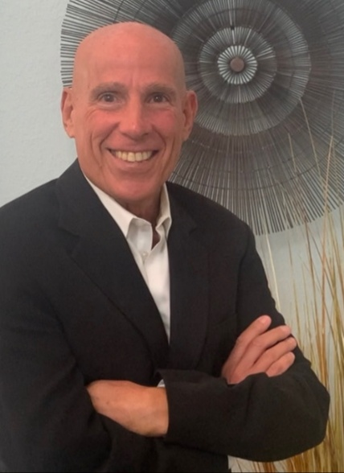
From Vision To Reality: Breakthrough Business Results
For over 35 years, Tom has been working with individuals and organizations committed to mastering change. The last 27 years have been dedicated to working with CEOs and Senior Executive Teams of Fortune 500 businesses in supporting large-scale change and simultaneously producing breakthrough business results. These client projects have included post-merger and acquisition, start-up ventures, major changes in business model, design or product platforms and process re-engineering projects. He specializes in co-designing and facilitating projects that integrate organizational culture change. business transformation and breakthrough business performance. His work includes high-impact individual executive coaching. breakthrough executive team development and organizational mobilization around large-scale change. He has designed and facilitated many leadership programs in the course of his career.
His career has spanned work as a clinical psychologist and management consultant. He has held positions as Senior Consultant with The DiBianca –Berkman Group, a pioneer in organizational transformation consulting and VP in Computer Science Corporation within their Management Consulting Group. He has worked with CEOs and C-Suite Executives from Ocean Spray, Intel Corporation, Nabisco Foods, Bell Labs, J&J McNeil Nutritionals, Republic Bank of Trinidad and Tobago, Bank of Barbados. Pfizer, GE Financial Services Group, Godiva, Ralph Lauren, BASF, BP (London and Africa), Kraft Foods and Campbell Soup, among others.
Before his work in the corporate setting, Tom was a psychologist working in individual and family therapy. He brings the insights, sensitivities and learning of over 15 years of clinical work to his coaching of executives, teams and organizations in the corporate setting.
Tom holds a Master’s Degree in Psychology from Duquesne University and a Bachelor’s degree in Psychology and Biology from Fordham University, His published writings include articles entitled “Ending The Political Stranglehold in the Executive Suite” detailing the dimensions of a specific type of his executive coaching and “The Fleischmann’s Renewal”, depicting the inner workings of a very successful corporate culture and organizational transformation project Tom led.

Tom is consistently lauded by his clients for his ability to partner with them in
- Making behavioral and attitudinal changes that produce significant lift in personal satisfaction and business results
- Confronting and creatively addressing blind spots and persistent attitudes and behaviors that are in the way of enjoying outstanding success as leaders and managers
- Elevating the engagement and productivity of employees

D’Aquanni and Associates

PO Box 442, Gardiner, MT 59030
973.464.4734 (mobile)
tom@daquanni.com

